To make networks using MetaMapR v1.2.1 (https://github.com/dgrapov/MetaMapR)

You can take a look at the data format required by downloading the "metabolomics data".
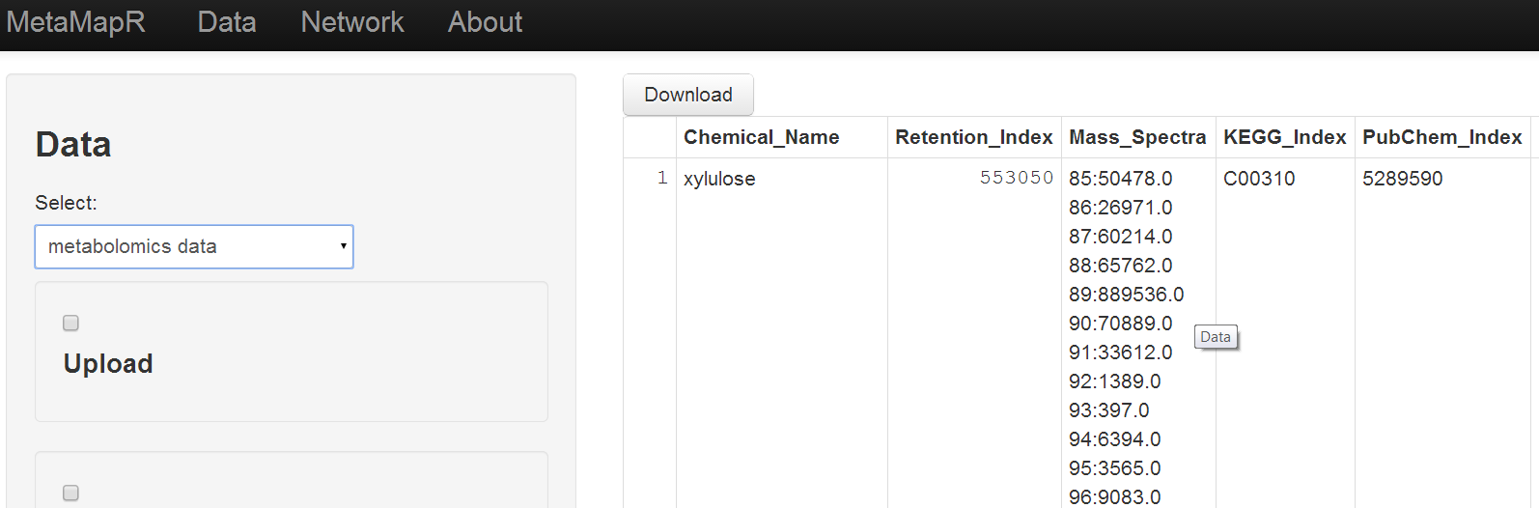

The data simply need to be in a csv. (column names help).
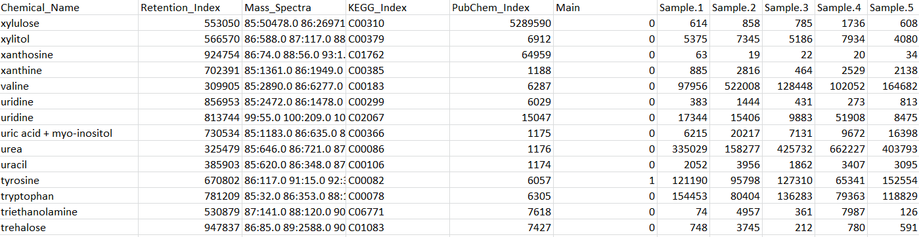

To make the networks you need to select which column in the data corresponds to the needed object.

For biochemical interactions you need KEGG IDs. Here is an example of this selection (I merely select the column in the data with KEGG IDs). If you don't have theses then you can translate from name to KEGG or other on the data--> translate tab.
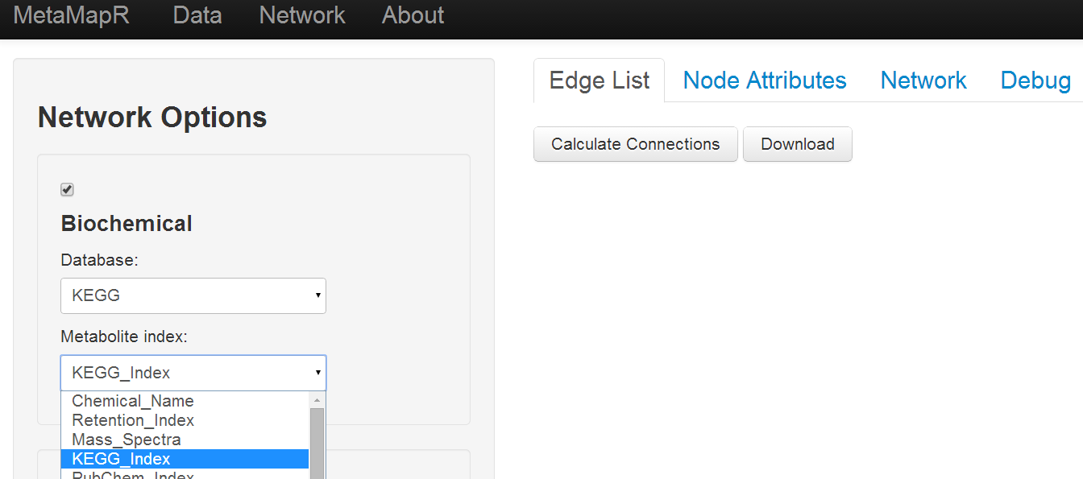
Once you made the selection hit the calculate connections button to get the edge list. Download this object to generate the network in Cytoscape. You will see how the node attributes match the edge IDs in the node attributes tab.

Here are the choices to make biochemical and structural similarity networks.
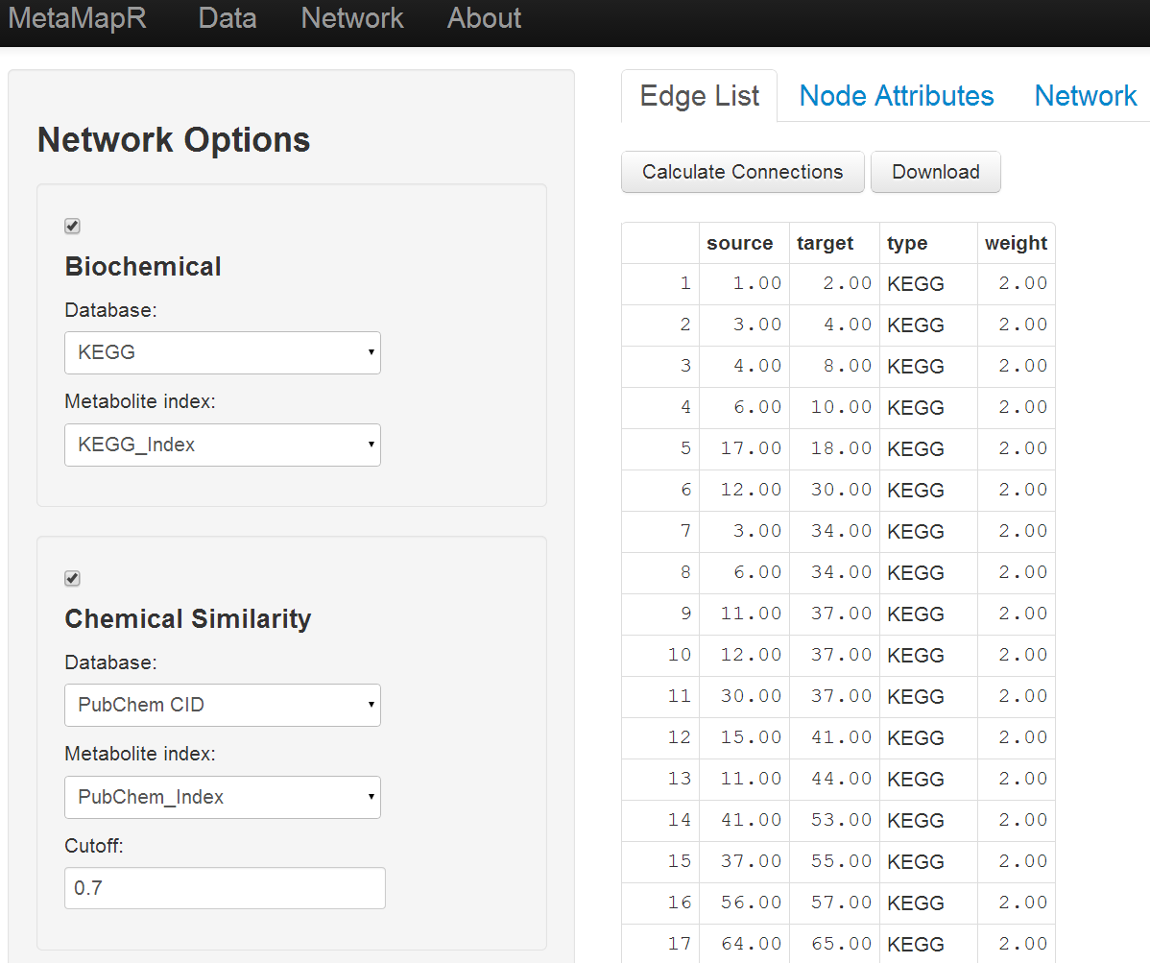

Alternatively you could make mass spectral similarity networks (or mix and match any connections).

To make mass spectral similarity networks you need data encoded like we do for BinBase and optionally supply the retention times. The Delta cutoff makes sure compounds are both spectrally similar and have similar retention times (in the window 10,000 units fro each other in the example above). You can also optionally give an index of 1s and 0s for (1,0,1,...) for which metabolites have names. This way only connections from unknown to known will be returned.
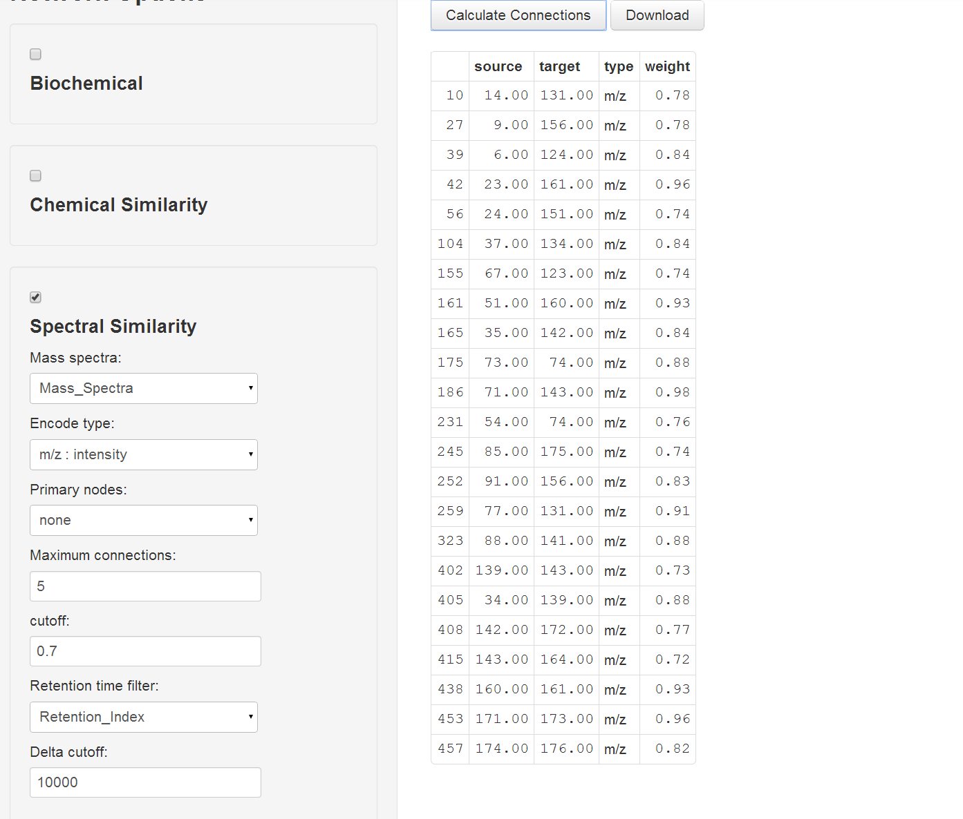

To build a network make sure you calculate the edge list first or make the need selections from the data, then use network tab to plot (may need to open options and hit plot to update). The network itself is more for overview and tuning the inputs, I would make the real networks in Cytoscape.
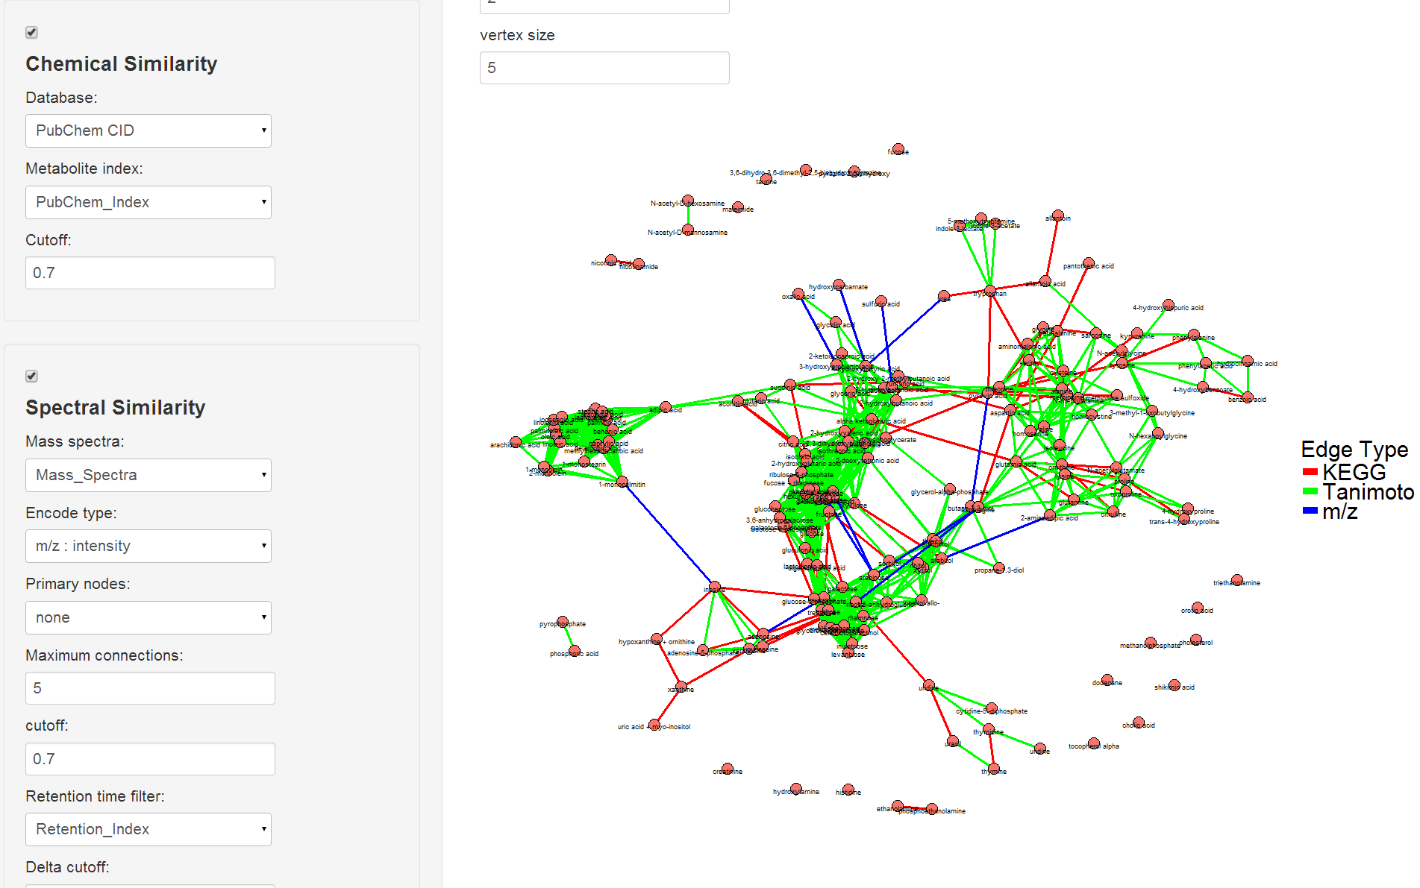

Recommendations and ~FAQ:

I would run MetaMapR locally and not use the server which has upload size limitations and only allows 1 user at a time.

Run locally by down loading the zip and use runApp("filepath") command or the shiny::runGitHub('MetaMapR','dgrapov') which downloads fresh copy eachtime.

The "error: attempt to set an attribute on NULL" happens when the program initializes, but should go away in a couple of seconds (could take longer on slower computers).

